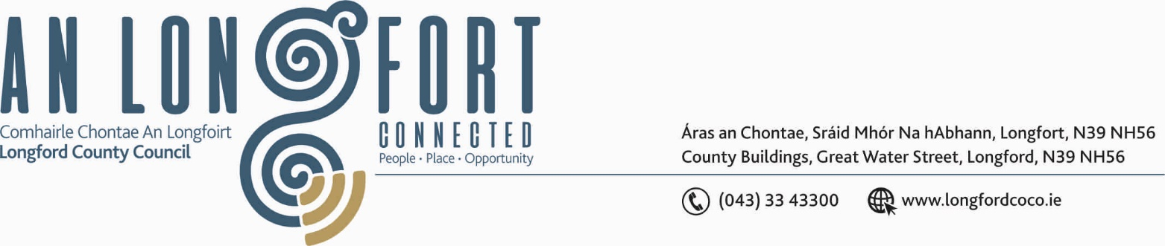

GRANARD MUNICIPAL DISTRICT

Corporate Affairs,
Aras an Chontae,
LONGFOIRT.

25th October 2018.

To: Each Member of the Granard Municipal District.

A Chomhairleoir,

You are requested to attend Meeting of Granard Municipal District on Thursday,
8th November 2018 at 4.00 p.m. in Granard Community Library –
to transact business, as set out on the Agenda hereunder.

Yours sincerely,
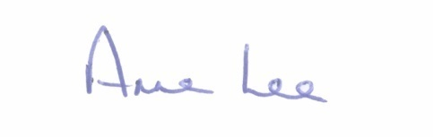

_______________
Anne Lee,
Meetings Administrator.

AGENDA

- Consideration of 2019-2021 Multi-Annual Restoration Improvement Programme.

- Consideration of the 2019 General Municipal Allocation.



